Top Tips for writing

• DO focus on letter formation. See sheet below. It’s really important that children get into the habit of writing letters correctly – this is not about how the finished letter looks, it’s all about how they write it – what direction they move the pencil or pen. Bad habits are almost impossible to break – if they form letters wrongly, the finished letter may look good BUT in the long run, they are much less likely to be able to write fluently.
• DON’T write a word or a line for them to copy. If they can’t remember how to write a letter, demonstrate, forming it correctly, so that they can imitate you.
• DO give loads of praise. Writing is so hard, and children get discouraged easily. It may be that they have just written one or two words, but if you praise them, it may be four words next time!
• DO write for them sometimes. It is important that young children can express their ideas in written form, and sometimes it is really good to write down what they say so that their ideas are expressed in writing on the page. Sometimes you can take turns to scribe. You write a bit, then they write a bit.

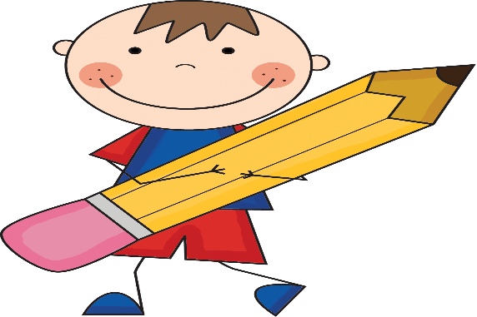
This Photo by Unknown Author is licensed under CC BY-SA-NC

Handwriting Letter Groups
There are basically 4 groups of letters – in terms of how we move the pen to write these.
1. Long Ladder Letters: Start at the top, go down and then off in another direction, e.g. i, j, l, t, u, y
2. One Armed Robot Letters: Start at the top, go down and retrace upwards, e.g. b, h, k, m, n, p, r
3. Curly Caterpillar Letters: Start at the top and go anticlockwise round, e.g. c, a, d, g, e, o, q, f, s
4. Zigzag Monster letters: Zigzag from top then down, e.g. v, w, x, z

