WALT find percentages of amounts
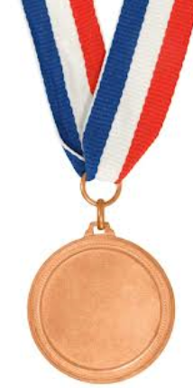  - 50% of 10  - 50% of 14  - 50% of 18  - 50% of 22  - 50% of 26  - 50% of 30  - 50% of 40  - 50% of 62 | 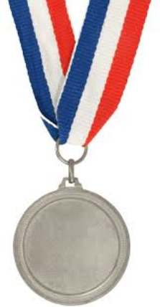  - Find 50% of:  2) Find 25% of:  a) 112  b) 64  c) 208  d) 3200  e) 2800  f) 4800  - 210  - 130  - 4200  - 1440  - 6400  - 5000 | 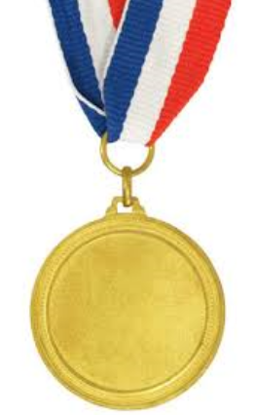  To find 10% we divide the amount by 10.  To find 1% we divide the amount by 100.  - 10% of 220  - 20% of 220  - 10% of 36  - 20% of 36  - 10% of 940  - 20% of 940  - 1% of 350  - 2% of 350  - 1% of 5600  - 3% of 5600  - 1% of 77  - 2% of 77
  100%
  50% | 50%
  100%
  50% |  | 50%
  25% | 25% | 25% | 25%
STAR CHALLENGE
You can use your knowledge of how to find 50%, 25%, 10% and 1% to find other percentages.
How could you calculate:
99% of 1600?
11% of 1600?
75% of 1600?
32% of 1600?

